Design Document

App Name: EZ Grocery List
Version: 1.0
Author: Ye Cheng

CSC780
Fall 2014
Ye Cheng

Table of Content
Platform and Software Used 3
Development Environment 3
Supported Platform 3
Project Wiki 4
Code Repository 4
Journal 4
Expected Deliverables 5
Project Overview 6
Purpose 6
Target Audience 6
Features 6
User Story 8
User Story - Pantry 8
User Story - Recipe 8
User Story – Grocery Shopping 9
Storyboards 10
Design for Main Screen 10
Design for Pantry List Screen 12
Design for Recipe List Screen 15
Design for Shopping List Screen 19
Design for Barcode Scanner Screen 22
Design for Text Input Screen 23
Design for Sharing by Email 25
Design for Voice Input Screen 26
Design for Setting Screen 27
Design for Information Screen 29
Future Features 30

Platform and Software Used

Development Environment
This app is developped under Eclipse IDE with built-in ADT (Android Developer Tools, v23.0.2). Android 4.4W (API20) is used in the Android SDK.

This app is tested using Google Nexus 5 device with Android 4.4.4 installed.

Supported Platform
The current version of this app supports Android 4.4.4.
Project Wiki

Code Repository
Project csc780 is created on Git hub for this app. The source codes for this app is stored and updated on Git hub code repository:
https://github.com/ycheng82/csc780

Journal
The weekly progress is recorded each week as a journal entry (wiki style) on the same Gib hub project:
https://github.com/ycheng82/csc780/wiki

This wiki also lists links to word doc and pdf version of the design document for this app.

Expected Deliverables
- By 10/8/2014: Finish design document for the app. Create git repository. Start adding journal pages.
- By 10/15/2014: Finish codes for main screen. Update journal pages.
- By 10/22/2014: Finish codes for pantry screen. Update journal pages.
- By 10/29/2014: Add function implementation to pantry screen. Update journal pages.
- By 11/5/2014: Finish codes for recipe screen. Update journal pages.
- By 11/12/2014: Finish codes for shopping screen. Update journal pages.
- By 11/19/2014: Finish codes for setting screen. Update journal pages.
- By 11/26/2014: Finish all app implementation and documents. Debug and testing. Update journal pages.
- By 12/3/2014: Fine tune and add-on features implementations of the app. Update journal pages.
- By 12/10/2014: Debug and testing. Update journal pages.
- By 12/17/2014: Finalize all app implementation and documents. Update journal pages.

Project Overview

Purpose
The purpose of this app is to make your grocery shopping easy by creating, editing, monitoring your own grocery inventory.
Bring your pantry inventory along with you all the time!
Using this app, you can create you own list for your pantry items. You can also create your own recipe lists. Based on the pantry list, you can easily add items to a grocery shopping list when you think the stock is low.
Never forget anything for your party!
Another useful feature provided by this app is to create a shopping list based on recipe list. This makes your life easy when you decide what meals you are going to make and then start shopping for them. This makes you never forget an item for your meal plan.
Easy input method when you have your hands full!
This app provides three different input method: keyboard text input, voice input and barcode scanner. No matter when you have your hands full, or just have the empty box, you can easily add your item to the list.

Target Audience
The target audience of this app is people who wants to make use of their mobile device for their grocery shopping. This is not limited to housewives who are busy to manage their weekly grocery shopping. It can also be used by college students, schools, restaurants to monitor their own pantry or inventory list, make a grocery shopping list based on that, and update it after they purchase more grocery items.

Features
The following functions are provided by the 1.0 version of this app:
- Manage your pantry list
  - Create a pantry list
  - Edit a pantry list
    - Add an item to the list
    - Edit the property of an item
      - Change the quantity
      - Change the unity
      - Change the category
      - Change the price
      - Add a note
    - Delete an item from the list
    - Edit the name and category of this pantry list
    - Remove this pantry list
    - Share this pantry list with someone
  - Add items from your pantry list to a grocery shopping list
- Manage your recipe list
  - Create a recipe list
  - Edit a recipe list
    - Add a recipe to the list
    - Edit a recipe in the list
      - Add ingredients to the recipe
      - Change the quantity of an ingredient
      - Delete an ingredient from the list
      - Add and edit instructions to the recipe
      - Add images to the recipe
    - Remove a recipe from the list
    - Edit the name and category of this recipe list
    - Remove this recipe list
    - Share this recipe list with someone
  - Create a grocery shopping list based on the ingredients for a recipe list
- Manage your grocery shopping list
  - Create a shopping list
  - Edit a shopping list
    - Add an item to the list
    - Edit the property of an item
      - Change the quantity
      - Change the unity
      - Change the category
      - Change the price
      - Add a note
    - Delete an item from the list
    - Edit the name and category of this shopping list
    - Remove this shopping list
    - Share this shopping list with someone
    - Add an item from your pantry or recipe list to a grocery shopping list
    - Calculate the total price based on the selected items from a shopping list
- Provides three different input method for items names:
  - Text input (keyboard)
  - Voice input
  - Barcode scanner input

User Story

User Story - Pantry
1. As a user, I want to be able to know the current status of my pantry before or during or after I do a grocery shopping.
1) I can see the name of all my grocery items on a single screen, with the corresponding quantities listed.
2) I can tell from the color that the quantity of certain item is low and also a “buy” button displayer for me to add that to my grocery shopping list (future version)
3) I can assign a color for my pantry lists.
4) I can assign a category for my pantry list.

2. As a user, I want to be able to change the current status of my pantry after I do a grocery shopping.
1) I can add new item(s) to my pantry list with their name and quantity.
2) I can remove items or change item quantify for my pantry list.
3) I can add category information for my items.
4) I can check for items that are in my pantry and add items I want to buy to a shopping list
5) After I do my shopping, I can edit the pantry list (add new items, change quantity of existing items).

3. As a user, I want to be able to share my pantry information with someone else.
1) I can select one of my pantry lists.
2) I can add a message to it.
3) I can send this shopping list along with the message by email to someone.

User Story - Recipe
1. As a user, I want to be able to make my recipe list.
1) I can create a recipe list and give it a name.
2) I can assign a color for my recipe lists.
4) I can assign a category for my recipe list.

2. As a user, I want to be able add recipe to one my recipe list.
1) I add create a new recipe and add it to a desired recipe list.
2) In this new recipe, I can specify the ingredients with their quantity. I can also add instructions / steps to the recipe.
3) I can add pictures to the recipe if I want.

3. As a user, I want to be able remove a recipe from my recipe list.
1) I can choose the recipes that are no longer needed.
2) I can remove them from the recipe list.

4. As a user, I want to be able quickly create a grocery shopping list based on recipe or recipe list.
1) I can select several recipes or a recipe list.
2) I can choose to add the ingredients needed for these recipes to one of my grocery shopping list.

5. As a user, I want to be able to share my recipe information with someone else.
1) I can select one of my recipe lists.
2) I can add a message to it.
3) I can send this shopping list along with the message by email to someone..

User Story – Grocery Shopping
1. As a user, I want to be able to make my grocery shopping list.
1) I can create a grocery shopping list and give it a name.
2) I can assign a color for my shopping lists.
4) I can assign a category for my shopping list.

2. As a user, I want to be able add items to one my grocery shopping list.
1) I add new items to a desired shopping list.
2) I can also specify the quantity for each new item.
3) I can add category information for my items.

3. As a user, I want to be able remove items from my grocery shopping list.
1) I can choose the items that are no longer needed.
2) I can remove them from the shopping list.

4. As a user, I want to be able quickly create a grocery shopping list based on recipe, recipe list or pantry list.
1) See previous section.

5. As a user, I want to be able to share my grocery shopping information with someone else.
1) I can select one of my grocery shopping list.
2) I can add a message to it.
3) I can send this shopping list along with the message by email to someone.

Storyboards
All colors and texts for the figures in this section may be subtly changed during implementation.

Design for Main Screen
1. After you download and install the app, you will see an icon for the app (Figure 1) on your screen.
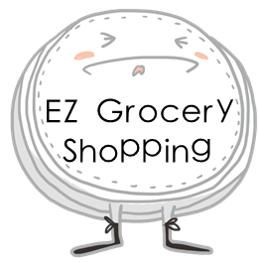
Figure 1. Icon for the app
2. You can click this icon, and this will open the app and bring you to the main screen for the app (figure 2).
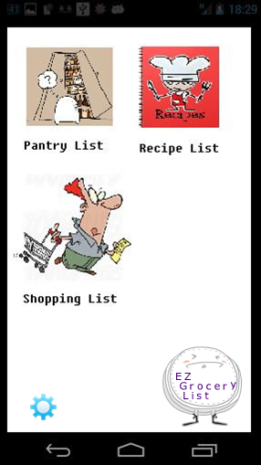
Figure 2. Main screen for the app
3. This screen has three icons (pantry list, recipe list and shopping list). Clicking each icon will bring to you another screen for the corresponding list (Figure 3).
4. This screen also has a setting icon which will bring you to the screen for thesetting of the app (Figure 3).
5. On the lower corner, there is another icon showoing the app name “EZ Grocery List”. Clicking this icon will bring you to another information screen which contains privacy information, term of use and author information (Figure 3).

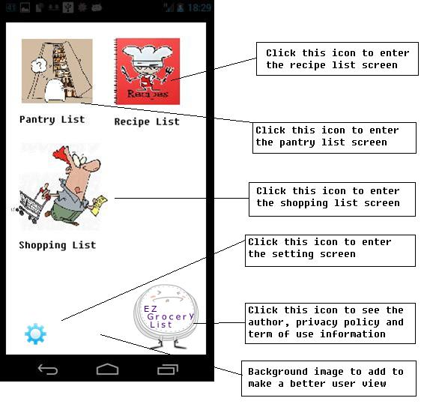
Figure 3. Instructions for main screen

Design for Pantry List Screen
1. After you enter the pantry list, you will see the main screen for pantry list (Figure 4 - 1). A default new pantry list has been created for first time user. This default list has the name “new list”.
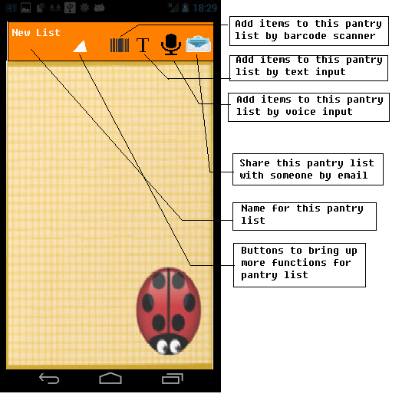
Figure 4 - 1. Main screen for pantry list
2. By clicking the buttons on the top of the screen, you can use three different input method to add things to your pantry list:
1) Barcode scanner (see design for barcode scanner screen section for more detail)
2) Text input (see design for text input screen section for more detail)
3) Voice input (see design for voice input screen section for more detail)
3. After you add items to your pantry list, you will see all the items with their quantity listed (Figure 4 - 2). You can also click the edit button on the right side of each item to edit item information (this brings back the item screen similar to Figure 8 - 1).
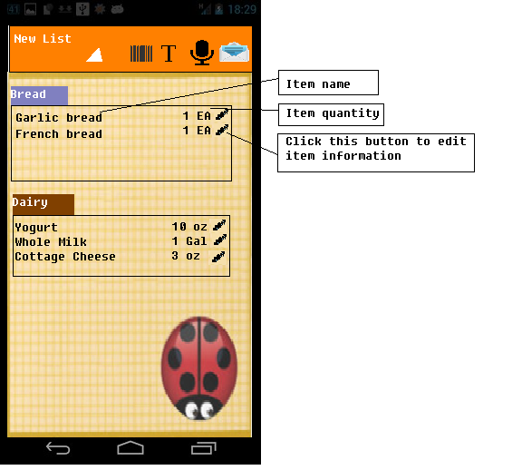
Figure 4 - 2. Pantry list with item name and quantity displayed
4. By clicking the mailing button on the top right of the screen, you can share this pantry list with someone else by email. (see design for sharing by email section for more detail)
5. By clicking the small white triangle, this brings up more functions for the pantry list (Figure 4 - 3):
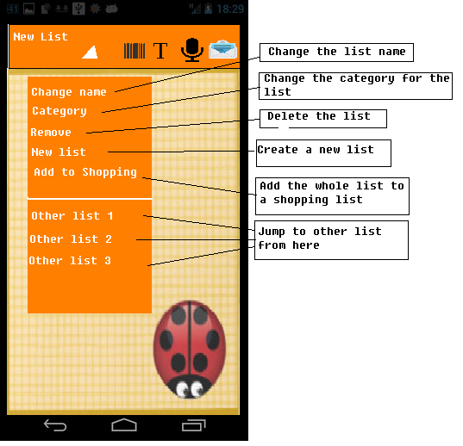
Figure 4 - 3. More functions for pantry list

1) Change your list name (keyboard input, Figure 8 - 2)
2) Change the category for your list (keyboard input, Figure 8 - 2)
3) Delete this list (alert dialog to confirm, Figure 4 - 4)
4) Create a new list (keyboard input, Figure 8 - 2; this will then bring you to main screen for a new list with the corresponding list name)
5) Add the whole list to a shopping list (drop down list to choose, which then brings to you the main screen for the corresponding shopping list)
6) Jump to other lists (bring you to the main screen for list with the corresponding list name). You can jump to any pantry list, recipe list or shopping list from here.
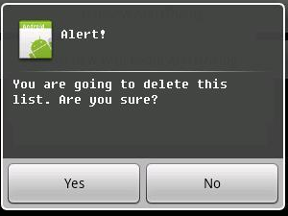
Figure 4 - 4. Alert dialog to confirm action for deleting a list

Design for Recipe List Screen
1. After you enter the recipe list, you will see the main screen for recipe list (Figure 5 - 1). A default new recipe list has been created for first time user. This default list has the name “new list”.
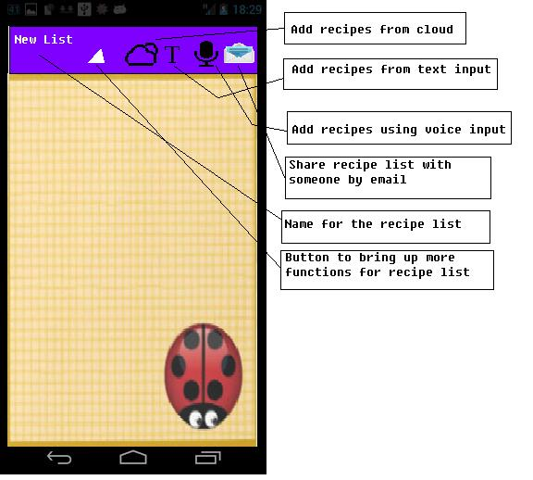
Figure 5 - 1. Main screen for recipe list
2. By clicking the buttons on the top of the screen, you can use three different input method to add a recipe to your recipe list:
1) Cound / online database (will be implemented in verision 2.0)
2) Text input (keyboard input, Figure 8 - 2)
3) Voice input (see design for voice input screen section for more detail)
3. After you add recipe to your pantry list, you will see all the recipe with their name listed (Figure 5 - 2).
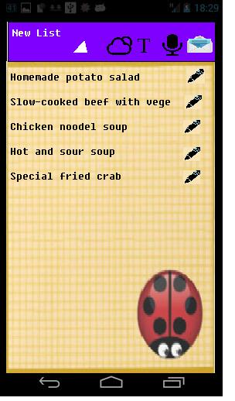
Figure 5 - 2. Recipe with name listed for the recipe list
You can also click the edit button on the right side of each item to edit the recipe information (Figure 5 - 3). Click add or edit button for ingredients or stpes brings you to the edit screen for recipe item or stepe detail (Figure 5 - 4). Click add or edit button for images brings you to the file chooser for your image (Figure 5 - 5).
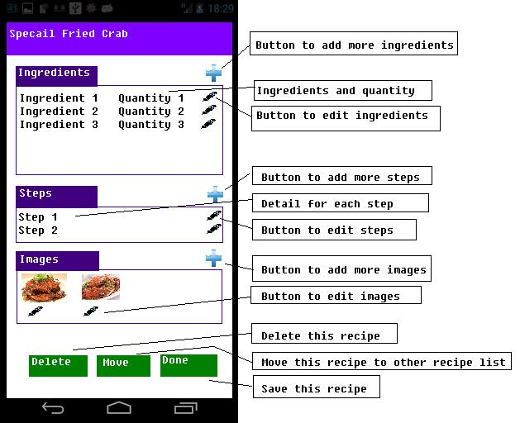
Figure 5 - 3. Recipe information with edit options

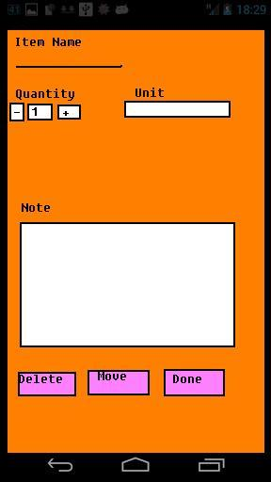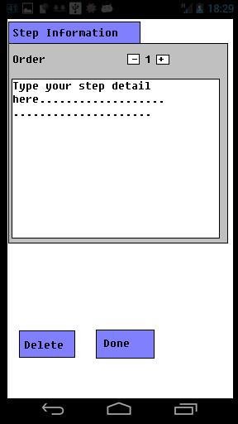
Figure 5 – 4. Edit screen for recipe item (left) and step information (right)
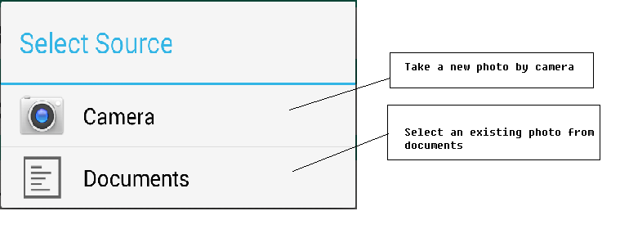
Figure 5 – 5. Use images from camera or documents
4. By clicking the mailing button on the top right of the screen, you can share this recipe list with someone else by email. (see design for sharing by email section for more detail)
5. By clicking the small white triangle, this brings up more functions for the recipe list (Figure 5 - 6):
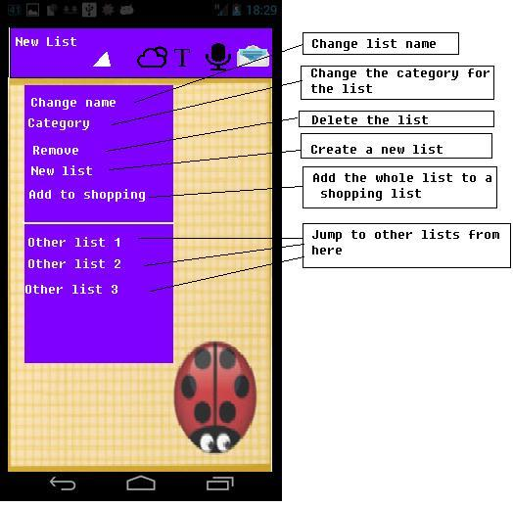
Figure 5 - 6. More functions for recipe list
1) Change your list name (keyboard input, Figure 8 – 2)
2) Change the category for your list (keyboard input, Figure 8 – 2)
3) Delete this list (alert dialog to confirm, Figure 4 - 4)
4) Create a new list (keyboard input, Figure 8 – 2; after you hit “done”, bring you to main screen for recipe list with the corresponding list name)
5) Add the whole list to a shopping list (drop down list to choose)
6) Jump to other lists (bring you to main screen for list with the corresponding list name). You can jump to any pantry list, recipe list or shopping list from here.

Design for Shopping List Screen
1. After you enter the recipe list, you will see the main screen for shopping list (Figure 6 - 1). A default new shopping list has been created for first time user. This default list has the name “new list”.
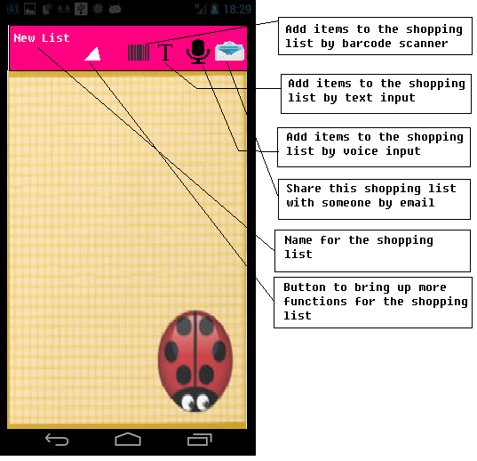
Figure 6 - 1. Main screen for recipe list
2. By clicking the buttons on the top of the screen, you can use three different input method to add things to your shopping list:
1) Barcode scanner (see design for barcode scanner screen section for more detail)
2) Text input (see design for test input section for more detail)
3) Voice input (see design for voice input screen section for more detail)
3. After you add items to your shopping list, you will see all the items with their quantity listed (Figure 6 - 2). You can also click the edit button on the right side of each item to edit item information (this brings back the item screen similar to Figure 8 - 1).
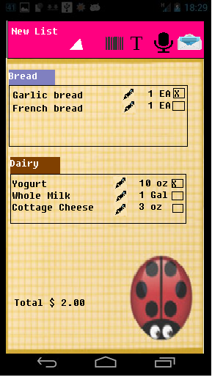
Figure 6 - 2. Shopping list with item name, quantity and total price displayed. Check the items you want to calculate for the total price.
4. By clicking the mailing button on the top right of the screen, you can share this shopping list with someone else by email. (see design for sharing by email section for more detail)
5. By clicking the small white triangle, this brings up more functions for the pantry list (Figure 6 - 3):
1) Change your list name (keyboard input, Figure 8 – 2)
2) Change the category for your list (keyboard input, Figure 8 – 2)
3) Delete this list (alert dialog to confirm, Figure 4 - 4)
4) Create a new list (keyboard input, Figure 8 – 2; after you hit “done”, bring you to main screen for recipe list with the corresponding list name)
5) Jump to other lists (bring you to main screen for list with the corresponding list name). You can jump to any pantry list, recipe list or shopping list from here.
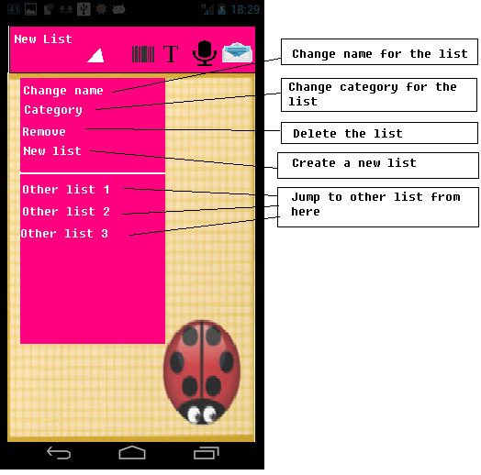
Figure 6 - 3. More functions for shopping list

Design for Barcode Scanner Screen
1. After you click any barcode scanner input button, this will bring you to the barcode scanner screen (Figure 7 - 1).
2. It bascially looks like a camera. You need to align the barcode of your item within the box on the screen.
3. After you align it for 5 sec, it will start scanning. This looks for items in the local barcode database plus the items you manually input.
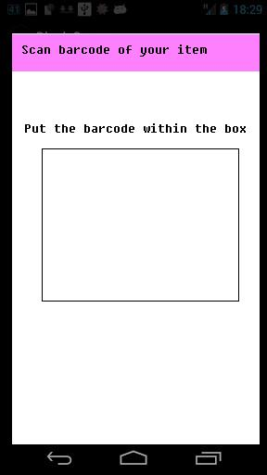
Figure 7 - 1. Barcode scanner screen
4. After a successful scanning, it will bring you to the item input screen with the item name already included (see design for text input section for more detail, Figure 8 - 1). If the scanning is not successful, it will pop up an alert screen (Figure 7 - 2). This alert asks if the user wants to try again or cancel and return back.
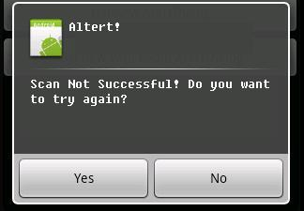
Figure 7 - 2. Alert screen for an unsuccessful scanning

Design for Text Input Screen
1. After you click any text input button, this will bring you to the text input screen (Figure 8 - 1).
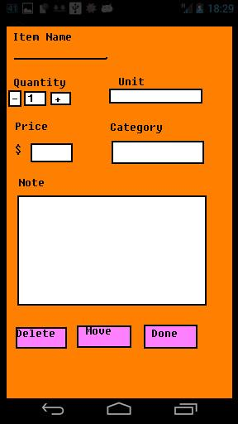
Figure 8- 1. Text Input screen

2. You can type in the followoing information here:
1) Item name (keyboard input, Figure 8 - 2)
2) Item quantity (1 is default, use “+” or “-” button to change)
3) Unit (drop dow list to choose, Figure 8 - 3. If you click “other unit”, it will show a keyboard input for you to enter new unit name.)
4) Price (keyboard input, Figure 8 - 2)
5) Category (drop down list to choose, Figure 8 - 3. If you click “new”, it will show a keyboard input for you to enter new category name.)
6) Note (keyboard input, Figure 8 - 3)

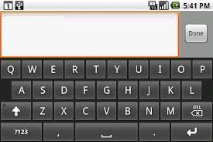
Figure 8- 2. Keyboard input

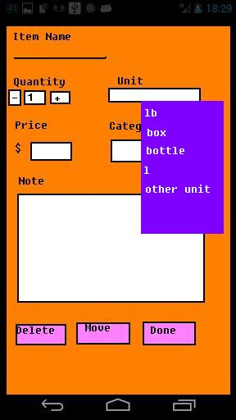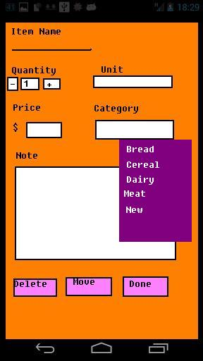
Figure 8- 3. Drop down for unit and category

3. Three buttons for three actions:
1) Delete: delete this item (switch you back to your previous screen)
2) Move: move this item to another list (drop down list to choose)
3) Done: save this item (show item information on your previous screen, Figure 8 - 4 and Figure 8 - 5)

Design for Sharing by Email
1. After you click any sharing button, this will bring you to a gmail compose screen (Figure 9).
2. Your email addess is already there.
3. You can type or look for your friend’s email. You can also change it to a different email address if you want.
4. You can add cc or bcc for this.
5. The tile for email has been added. You can edit it as well.
6. The content of the email is from the list you choose to share. You can edit it as well.
7. Click the send button to share. Other gmail functions are also available.
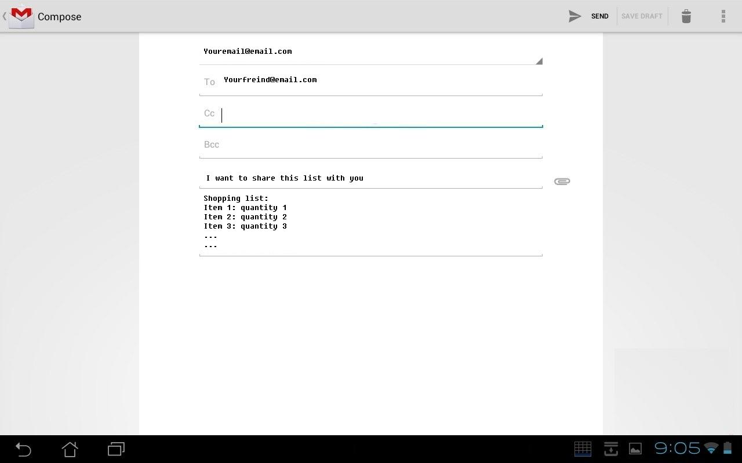
Figure 9. Compose an email to share the item with someone
8. After sending the mail successfully, a toast will show up and let you know message sent successfully.

Design for Voice Input Screen
1. After you click any sharing button, this will bring you to a gmail compose screen (Figure 10 - 1).
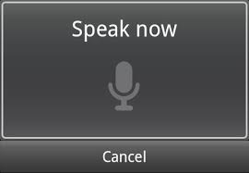
Figure 10 - 1. Voice input
2. If your voice is recognized, based on what screen you come from, it will bring you back (for example, an item input screen Figure 8 – 1). The recognized word will be put automatically as the name for the list.
3. If you voice is not recognized, it will pop up an alert screen (Figure 7 - 2). This alert asks if the user wants to try again or cancel and return back.
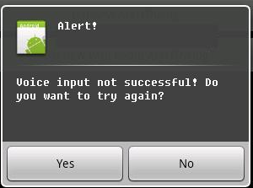
Figure 10 - 2. Alert screen for an unrecognizable voice

Design for Setting Screen
1. If you click the setting icon after you open the app, you will see the screen for setting options (Figure 11 - 1).
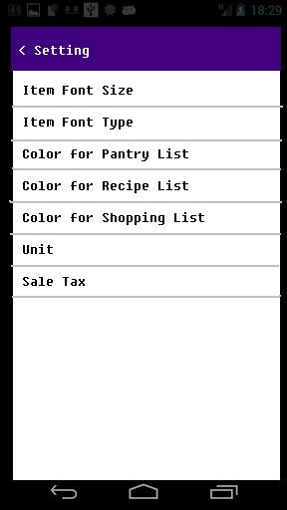
Figure 11 - 1. Screen for setting options
2. This app provides the following setting options:
1) Item font size: click this will pop up a window for you to choose font size (Figure 11 - 2). You can choose one of the three (large, medium and small)
2) Item font type: click this will pop up a window for you to choose font (Figure 11 - 2). You can choose one of the provided fonts.
3) Color for pantry list: click this will pop up a window for you to choose a color for your pantry list (Figure 11 - 3)
4) Color for recipe list: click this will pop up a window for you to choose a color for your recipe list (Figure 11 - 3)
5) Color for shopping list: click this will pop up a window for you to choose a color for your shopping list (Figure 11 - 3)
6) Unit: click this will pop up a window for you to choose either US or metric as your unit for items (Figure 11 - 4)
7) Sale Tax: click this will pop up a window for you to type in the sale tax value you want (Figure 11 - 5)
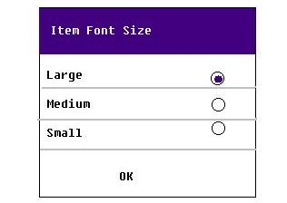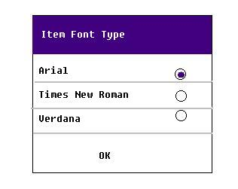
Figure 11 - 2. Screen for choosing item font size (left) and font type (right)
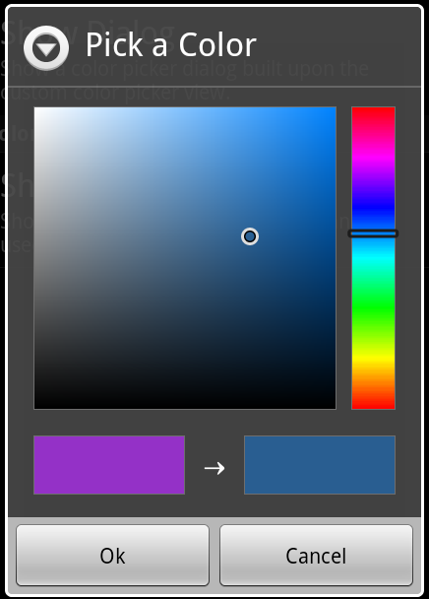
Figure 11 - 3. Screen for choosing a color for your list
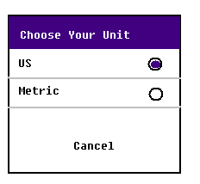
Figure 11 - 4. Screen for choosing unit for your item
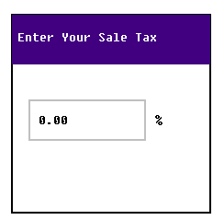
Figure 11 - 5. Screen for input your sale tax
Design for Information Screen
1. If you click the logo icon after you open the app, you will see the screen for app information (Figure 12 - 1).
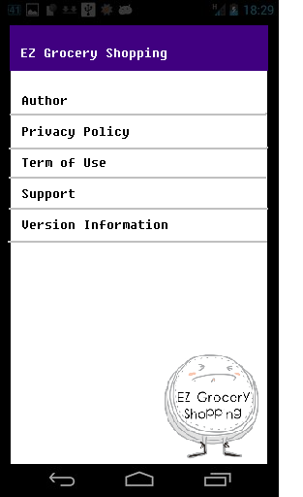
Figure 12 - 1. Screen for app information
2. Click each of them will pop up a window with relative information listed (similar to the privacy policy screen shown Figure 12 - 2)
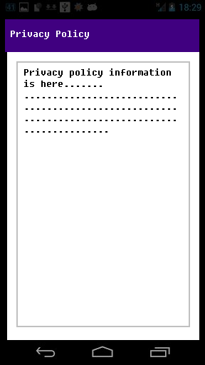
Figure 12 - 2. Screen for privacy information
Future Features
Following features will be added in furture version of this app. If time permits, some of them may be implemented in the current version v1.0.
1. Add recipes from online database or cloud
2. Edit functions for recipe image (change brightness, resize, cut etc.)
3. Different theme options for pantry list, recipe list or shopping list
4. NFC to communite between fridge or other devices
5. Use location to get local grocery deal or promotion information
6. Add options for setting the threshold for “low and buy”, which will automatically reminds you to purchase an item when its stock is low

